1)FAQ open/close
DOM selection + Event Handling + FAQ open/close

Code:
FAQ.html
<button class="faq-btn">
1. What is StudentHub?
<span>+</span>
</button>

<div class="faq-answer">
<p>
StudentHub is an online portal...
</p>
</div>
Myscript.js
const faqButtons = document.querySelectorAll(".faq-btn");

faqButtons.forEach(function(button){
button.addEventListener("click", function(){

const answer = this.nextElementSibling;
const icon = this.querySelector("span");

document.querySelectorAll(".faq-answer").forEach(function(item){
if(item !== answer){
item.style.display = "none";
}
});

if(answer && answer.style.display === "block"){
answer.style.display = "none";
if(icon) icon.innerHTML = "+";
}
else if(answer){
answer.style.display = "block";
if(icon) icon.innerHTML = "−";
}
});
});
ScreenShort:

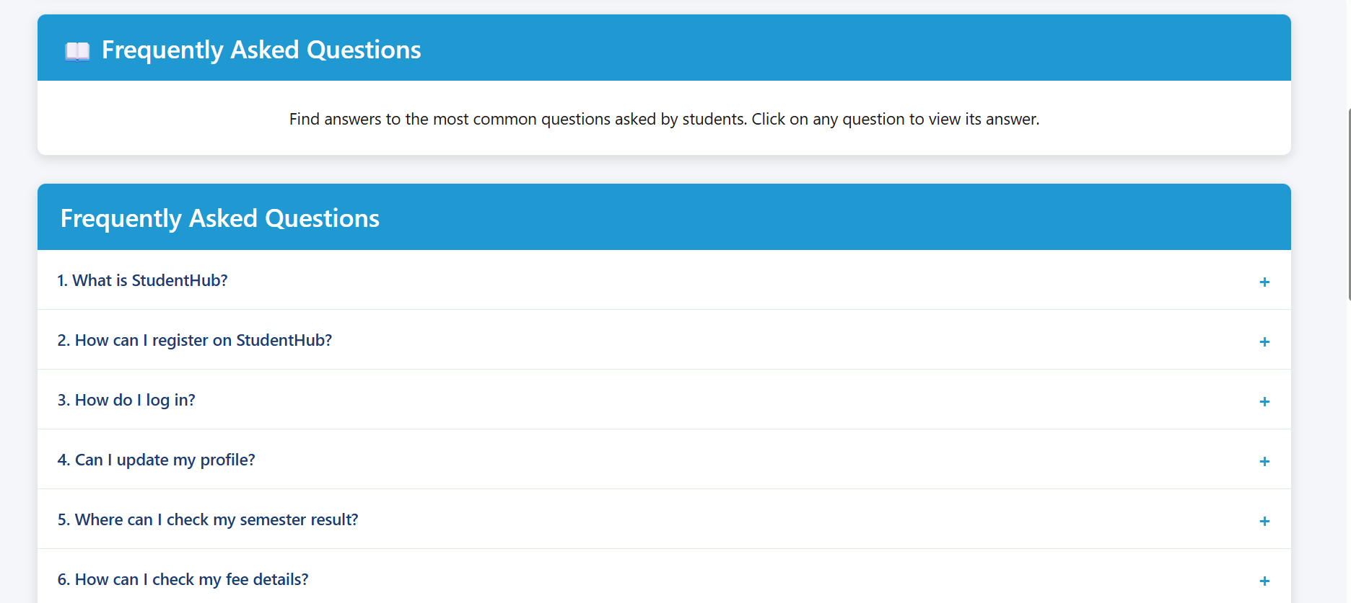

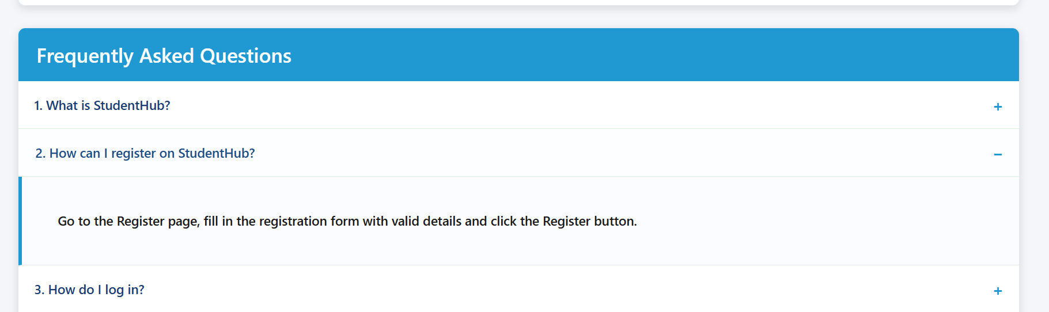

2)Modal Popup
Modal + Event Handling + DOM manipulation

Code:
FAQ.html
<button class="help-btn" id="openModal">
Contact Support
</button>

<div class="modal" id="supportModal">

<div class="modal-content">

<button id="closeModal" class="close">&times;</button>

<h2>Contact Support</h2>

<p>If you have any questions, feel free to contact us!</p>

<p><strong>Email:</strong> support@studenthub.com</p>

<p><strong>Phone:</strong> +91 98765 43210</p>

</div>

</div>
Myscript.js
const modal = document.getElementById("supportModal");
const openModal = document.getElementById("openModal");
const closeModal = document.getElementById("closeModal");

if(openModal && modal){
openModal.addEventListener("click", function(){
modal.style.display = "block";
});
}

if(closeModal && modal){
closeModal.addEventListener("click", function(){
modal.style.display = "none";
});
}
ScreenShort:

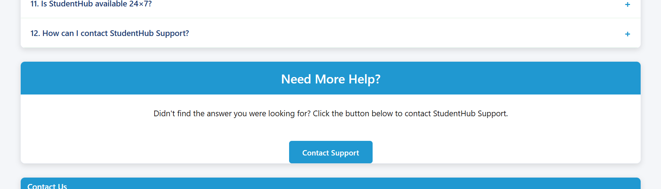

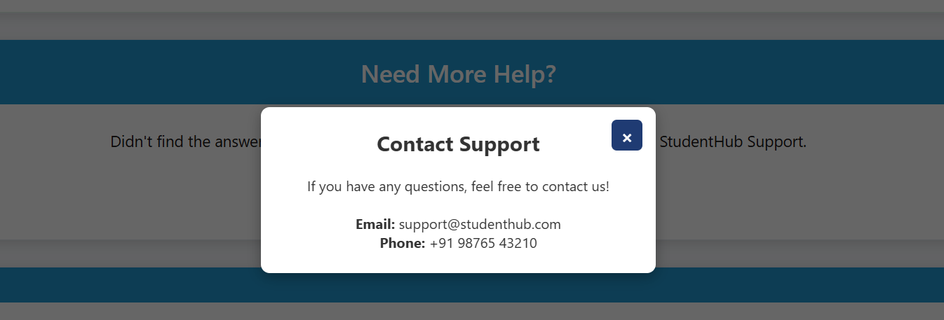

3)Content Slider
Content Slider + DOM modification

Code:
FAQ.html

<div class="slider" id="slider">
Welcome to StudentHub FAQ Center
</div>

myscript.js

const slider = document.getElementById("slider");

const slides = [
"📖 Welcome to StudentHub FAQ Center",
"🎓 Student Registration Made Easy",
"📢 Check Latest Events & Announcements",
"💳 View Fees & Payment Details",
"🏆 Access Your Semester Results"
];

let current = 0;

if (slider) {
setInterval(function () {
current++;

if (current >= slides.length) {
current = 0;
}

slider.innerHTML = slides[current];

}, 3000);
}

ScreenShort:

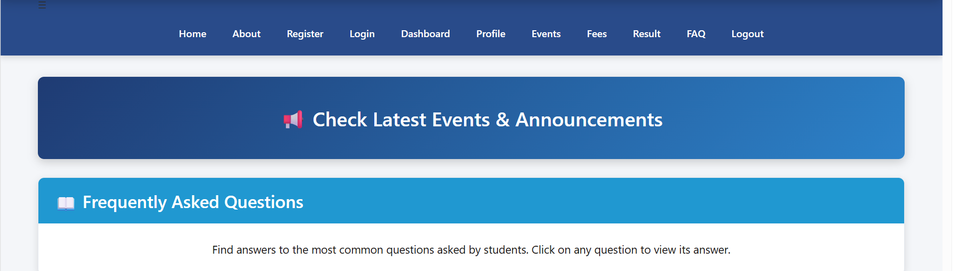

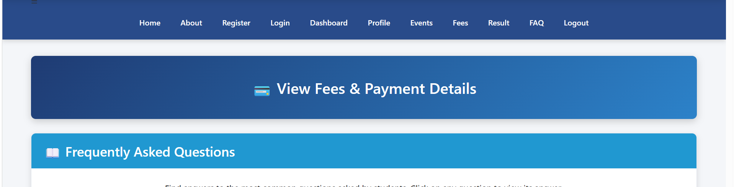

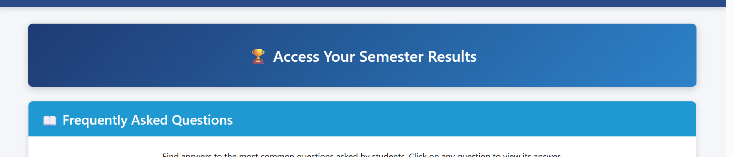

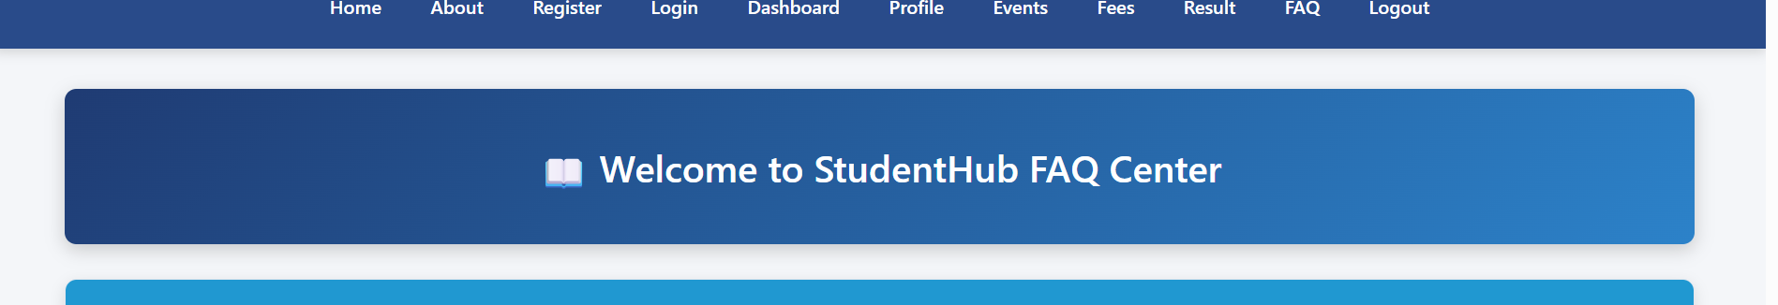

4)Hamburger Menu

Code:
Home.html
<div class="menu" id="menuBtn">☰</div>

<nav id="navbar">

<a href="home.html">Home</a>
<a href="about.html">About</a>
<a href="register.html">Register</a>
...

</nav>
Myscript.js
const menuBtn = document.getElementById("menuBtn");
const navbar = document.getElementById("navbar");

if(menuBtn && navbar){
menuBtn.addEventListener("click", function(){

if(navbar.style.display === "flex"){
navbar.style.display = "none";
}
else {
navbar.style.display = "flex";
navbar.style.flexDirection = "column";
navbar.style.alignItems = "center";
}

});
}

Style4.css

@media (max-width:768px){

.menu{
display:block;
font-size:34px;
color:white;
cursor:pointer;
text-align:center;
padding:15px;
}

nav{
display:none;
flex-direction:column;
align-items:center;
width:100%;
background:#294B8A;
}
}
ScreenShort:

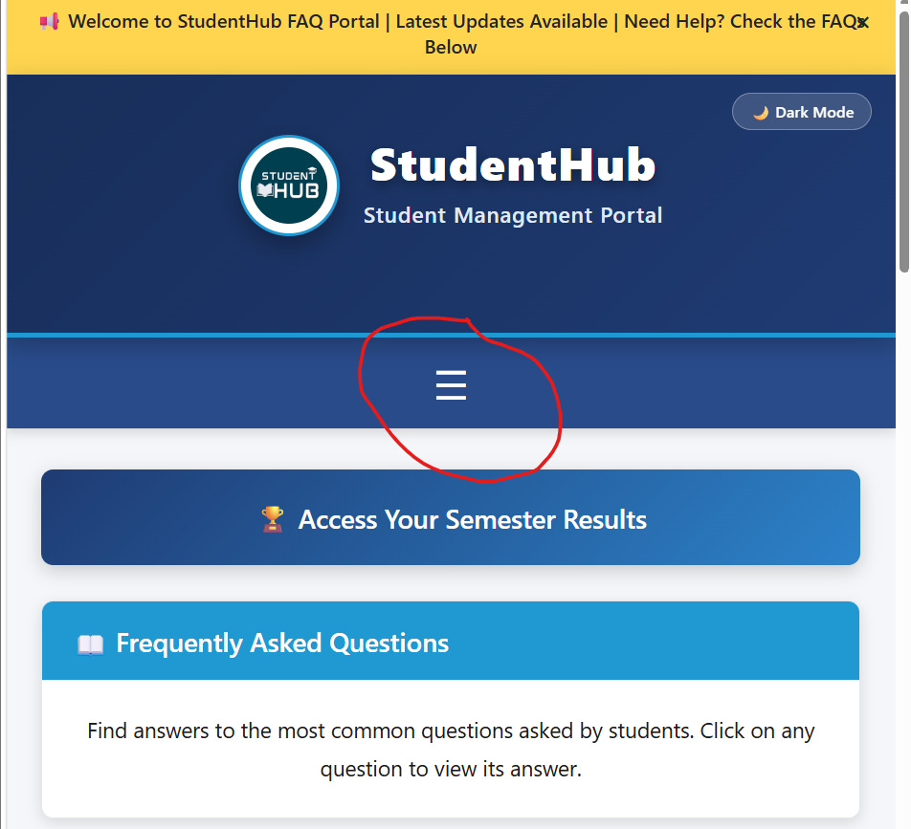

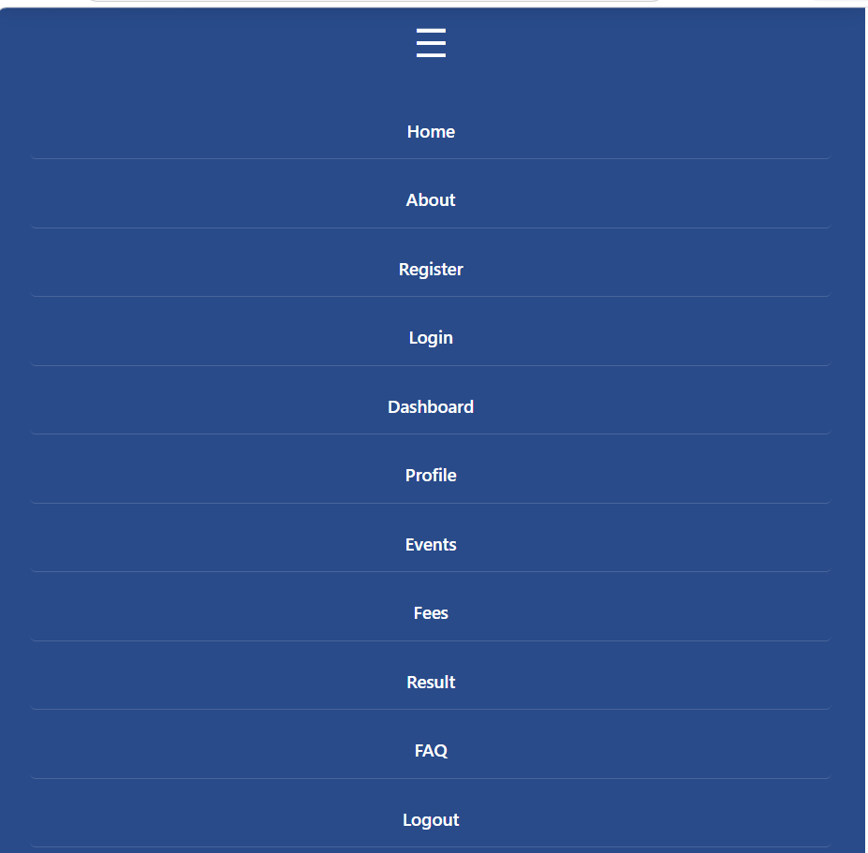

5)Light/Dark + localStorage
Code:
Myscript.js
const themeBtn = document.getElementById("themeBtn");

if (localStorage.getItem("theme") === "dark") {

document.body.classList.add("dark");

if (themeBtn) {
themeBtn.innerHTML = "☀ Light Mode";
}
}

if (themeBtn) {

themeBtn.addEventListener("click", function () {

document.body.classList.toggle("dark");

if (document.body.classList.contains("dark")) {

themeBtn.innerHTML = "☀ Light Mode";

localStorage.setItem("theme", "dark");

} else {

themeBtn.innerHTML = "🌙 Dark Mode";

localStorage.setItem("theme", "light");
}

});
}

ScreenShort:

Light Mode:

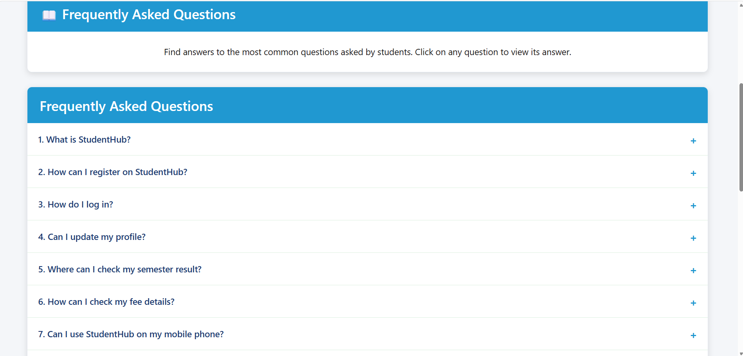

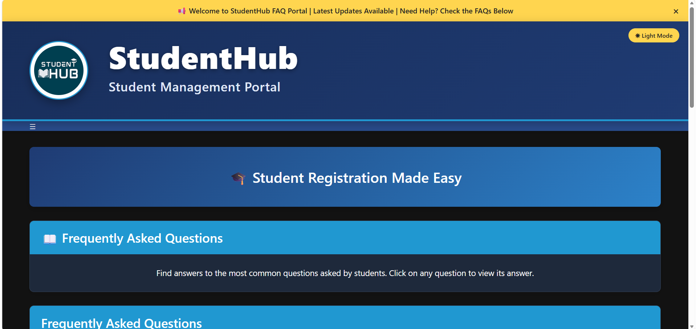

Dark Mode:

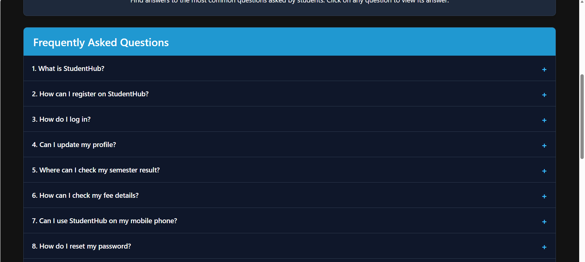

6)Notification Banner
DOM selection + Event Handling + Notification Banner

Code:
FAQ.html
<div class="banner" id="banner">

📢 Welcome to StudentHub FAQ Portal |
Latest Updates Available |
Need Help? Check the FAQs Below

<span id="closeBanner">&times;</span>

</div>

Myscript.js

const banner = document.getElementById("banner");
const closeBanner = document.getElementById("closeBanner");

if (closeBanner && banner) {
closeBanner.addEventListener("click", function () {
banner.style.display = "none";
});
}

ScreenShort:

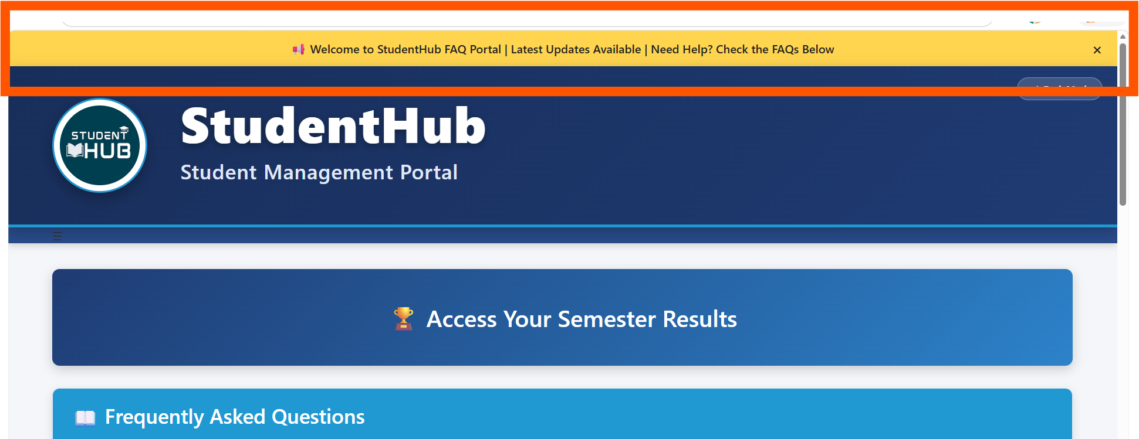

All codes:

FAQ.html

<!DOCTYPE html>
<html lang="en">

<head>

<meta charset="UTF-8">

<meta name="viewport" content="width=device-width, initial-scale=1.0">

<title>StudentHub | FAQ</title>

<link rel="stylesheet" href="style4.css">

</head>

<body>

<!-- ===============================
NOTIFICATION BANNER
================================ -->

<div class="banner" id="banner">

📢 Welcome to StudentHub FAQ Portal |
Latest Updates Available |
Need Help? Check the FAQs Below

<span id="closeBanner">&times;</span>

</div>

<!-- ===============================
HEADER
================================ -->

<header>

<div class="container">

<div class="top">

<div class="logo">

<img src="image.jpg">

<div>

<h1>StudentHub</h1>

<h3>Student Management Portal</h3>

</div>

</div>
<button class="theme-btn" id="themeBtn">🌙 Dark Mode</button>
</div>

</div>

</header>

<!-- Navigation Section -->

<div class="nav-section">

<div class="container">

<div class="menu" id="menuBtn">☰</div>

<nav id="navbar">

<a href="home.html">Home</a>

<a href="about.html">About</a>

<a href="register.html">Register</a>

<a href="login.html">Login</a>

<a href="dashboard.html">Dashboard</a>

<a href="profile.html">Profile</a>

<a href="event.html">Events</a>

<a href="fees.html">Fees</a>

<a href="result.html">Result</a>

<a href="FAQ.html">FAQ</a>

<a href="logout.html">Logout</a>

</nav>

</div>

</div>
<main>

<!-- ===============================
IMAGE / CONTENT SLIDER
================================ -->

<div class="slider" id="slider">

Welcome to StudentHub FAQ Center

</div>

<!-- ===============================
FAQ INTRODUCTION
================================ -->

<div class="card">

<h2>📖 Frequently Asked Questions</h2>

<p style="text-align:center;">

Find answers to the most common questions asked by students.
Click on any question to view its answer.

</p>

</div>

<!-- ======================================
FAQ SECTION
====================================== -->

<div class="card">

<h2>Frequently Asked Questions</h2>

<button class="faq-btn">

1. What is StudentHub?

<span>+</span>

</button>

<div class="faq-answer">

<p>

StudentHub is an online portal that helps students manage academic information, results, fees, events and profiles.

</p>

</div>

<button class="faq-btn">

2. How can I register on StudentHub?

<span>+</span>

</button>

<div class="faq-answer">

<p>

Go to the Register page, fill in the registration form with valid details and click the Register button.

</p>

</div>

<button class="faq-btn">

3. How do I log in?

<span>+</span>

</button>

<div class="faq-answer">

<p>

Enter your registered Email ID and Password on the Login page and click Login.

</p>

</div>

<button class="faq-btn">

4. Can I update my profile?

<span>+</span>

</button>

<div class="faq-answer">

<p>

Yes. Visit the Profile page and update your personal or academic information.

</p>

</div>

<button class="faq-btn">

5. Where can I check my semester result?

<span>+</span>

</button>

<div class="faq-answer">

<p>

Open the Result page from the navigation menu to view your semester examination results.

</p>

</div>

<button class="faq-btn">

6. How can I check my fee details?

<span>+</span>

</button>

<div class="faq-answer">

<p>

Visit the Fees page to view your fee payment status and receipt information.

</p>

</div>

<button class="faq-btn">

7. Can I use StudentHub on my mobile phone?

<span>+</span>

</button>

<div class="faq-answer">

<p>

Yes. StudentHub is fully responsive and works on desktops, tablets and smartphones.

</p>

</div>

<button class="faq-btn">

8. How do I reset my password?

<span>+</span>

</button>

<div class="faq-answer">

<p>

Click on the Forgot Password option on the Login page and follow the instructions.

</p>

</div>

<button class="faq-btn">

9. Where can I see upcoming events?

<span>+</span>

</button>

<div class="faq-answer">

<p>

Open the Events page to view workshops, seminars, hackathons and other campus activities.

</p>

</div>

<button class="faq-btn">

10. Which browser is recommended?

<span>+</span>

</button>

<div class="faq-answer">

<p>

Google Chrome, Microsoft Edge and Mozilla Firefox are recommended for the best experience.

</p>

</div>

<button class="faq-btn">

11. Is StudentHub available 24×7?

<span>+</span>

</button>

<div class="faq-answer">

<p>

Yes. StudentHub services are available 24 hours a day with an internet connection.

</p>

</div>

<button class="faq-btn">

12. How can I contact StudentHub Support?

<span>+</span>

</button>

<div class="faq-answer">

<p>

You can contact the StudentHub Support Team through the Contact Support button or using the email and phone number given below.

</p>

</div>

</div>

<!-- ===============================
NEED MORE HELP
================================ -->

<div class="card" style="text-align:center;">

<h2>Need More Help?</h2>

<p>

Didn't find the answer you were looking for?

Click the button below to contact StudentHub Support.

</p>

<br>

<button class="help-btn" id="openModal">

Contact Support

</button>

</div>

<!-- ======================================
CONTACT SUPPORT MODAL (POPUP)
====================================== -->
<!-- id="contactModal" ની જગ્યાએ id="supportModal" કરી દીધું છે -->
<div class="modal" id="supportModal">
<div class="modal-content">
<button id="closeModal" class="close">&times;</button>
<h2>Contact Support</h2>
<br>
<p>If you have any questions, feel free to contact us!</p>
<br>
<p><strong>Email:</strong> support@studenthub.com</p>
<p><strong>Phone:</strong> +91 98765 43210</p>
</div>
</div>

<!-- ======================================
CONTACT SUPPORT
====================================== -->

<div class="card contact-card">
<h2>Contact Us</h2>
<div class="contact-info">
<h3>StudentHub Portal</h3>
<p>📧 Email : studenthub@gmail.com</p>
<p>📞 Phone : +91 9876543210</p>
<p>📍 Address : CHARUSAT Campus, Changa, Gujarat 388421</p>
</div>
</div>

</main>

<!-- ======================================
FOOTER
====================================== -->
<footer>
<div class="footer-content">
<h2>StudentHub Portal</h2>
<p>Empowering Students Through Technology</p>
<p class="email">Email : studenthub@gmail.com</p>
<p class="copyright">&copy; 2026 StudentHub. All Rights Reserved.</p>
</div>
</footer>

<!-- ======================================
JAVASCRIPT FILE
====================================== -->

<script src="myscript.js"></script>

</body>

</html>

Contact Support

Home.html

<!DOCTYPE html>
<html lang="en">

<head>

<meta charset="UTF-8">
<meta name="viewport" content="width=device-width, initial-scale=1.0">

<title>StudentHub | Home</title>

<link rel="stylesheet" href="style4.css">

</head>

<body>

<!-- ===============================
HEADER
================================ -->

<header>

<div class="container">

<div class="top">

<div class="logo">

<img src="image.jpg">

<div>

<h1>StudentHub</h1>

<h3>Student Management Portal</h3>

</div>

</div>
<button class="theme-btn" id="themeBtn">🌙 Dark Mode</button>
</div>

</div>

</header>

<!-- Navigation Section -->
<div class="nav-section">

<div class="container">

<div class="menu" id="menuBtn">☰</div>

<nav id="navbar">

<a href="home.html">Home</a>

<a href="about.html">About</a>

<a href="register.html">Register</a>

<a href="login.html">Login</a>

<a href="dashboard.html">Dashboard</a>

<a href="profile.html">Profile</a>

<a href="event.html">Events</a>

<a href="fees.html">Fees</a>

<a href="result.html">Result</a>

<a href="FAQ.html">FAQ</a>

<a href="logout.html">Logout</a>

</nav>

</div>

</div>

<main>

<div class="card">

<h2>Welcome to StudentHub</h2>

<p>

StudentHub is an online portal designed to help students manage their academic activities. Students can register, log in, view their profile, check fees, access results, and stay updated with university events and notices.

</p>

</div>

<div class="card">

<h2>Student Services</h2>

<div class="services">

<div class="service">

<h3 style="color: #38bdf8 !important;">Student Registration</h3>

<p>Create a new student account and complete your registration online.</p>

</div>

<div class="service">

<h3 style="color: #38bdf8 !important;">Student Profile</h3>

<p>View and update your personal and academic information.</p>

</div>

<div class="service">

<h3 style="color: #38bdf8 !important;">Fees Details</h3>

<p>Check semester fee status and download payment receipts.</p>

</div>

<div class="service">

<h3 style="color: #38bdf8 !important;">Results</h3>

<p>View semester examination results quickly and securely.</p>

</div>

<div class="service">

<h3 style="color: #38bdf8 !important;">Events</h3>

<p>Stay updated with workshops, seminars and campus activities.</p>

</div>

<div class="service">

<h3 style="color: #38bdf8 !important;">Dashboard</h3>

<p>Access all student services from one convenient dashboard.</p>

</div>

</div>

</div>

<div class="row">

<div class="card">

<h2>Notice Board</h2>

<ul>

<li>Admissions Open for Academic Year 2026-27</li>

<li>Semester Examination Schedule Released</li>

<li>Hackathon Registration Starts Next Week</li>

<li>Library Timings Updated</li>

<li>Sports Week Registration is Now Open</li>

</ul>

</div>

<div class="card">

<h2>Latest News</h2>

<ul>

<li>Online Student Registration Portal is Now Live.</li>

<li>Web Development Workshop on Friday.</li>

<li>Mid-Sem Examination Dates Announced.</li>

<li>Scholarship Applications are Open.</li>

<li>Placement Training Begins Next Month.</li>

</ul>

</div>

</div>

<div class="card contact-card">
<h2>Contact Us</h2>
<div class="contact-info">
<h3>StudentHub Portal</h3>
<p>📧 Email : studenthub@gmail.com</p>
<p>📞 Phone : +91 9876543210</p>
<p>📍 Address : CHARUSAT Campus, Changa, Gujarat 388421</p>
</div>
</div>

</main>

<footer>
<div class="footer-content">
<h2>StudentHub Portal</h2>
<p>Empowering Students Through Technology</p>
<p class="email">Email : studenthub@gmail.com</p>
<p class="copyright">&copy; 2026 StudentHub. All Rights Reserved.</p>
</div>
</footer>
<script src="myscript.js"></script>
</body>

</html>

Myscript.js

/* ======================================
NOTIFICATION BANNER CLOSE
====================================== */
const banner = document.getElementById("banner");
const closeBanner = document.getElementById("closeBanner");

if (closeBanner && banner) {
closeBanner.addEventListener("click", function () {
banner.style.display = "none";
});
}

/* ======================================
IMAGE / CONTENT SLIDER
====================================== */
const slider = document.getElementById("slider");

const slides = [
"📖 Welcome to StudentHub FAQ Center",
"🎓 Student Registration Made Easy",
"📢 Check Latest Events & Announcements",
"💳 View Fees & Payment Details",
"🏆 Access Your Semester Results"
];

let current = 0;

if (slider) {
setInterval(function () {
current++;
if (current >= slides.length) {
current = 0;
}
slider.innerHTML = slides[current];
}, 3000);
}

/* ======================================
FAQ COLLAPSIBLE (ONE OPEN AT A TIME)
====================================== */
const faqButtons = document.querySelectorAll(".faq-btn");

faqButtons.forEach(function(button){
button.addEventListener("click", function(){
const answer = this.nextElementSibling;
const icon = this.querySelector("span");

// બીજો કોઈ ઓપન રહેલો જવાબ બંધ કરી દેશે
document.querySelectorAll(".faq-answer").forEach(function(item){
if(item !== answer){
item.style.display = "none";
}
});

// બાકી બધા બટન પર '+' કરી દેશે
document.querySelectorAll(".faq-btn span").forEach(function(item){
if(item !== icon && item){
item.innerHTML = "+";
}
});

// ક્લિક કરેલો આન્સર ટોગલ (ઓપન / ક્લોઝ) કરશે
if(answer && answer.style.display === "block"){
answer.style.display = "none";
if(icon) icon.innerHTML = "+";
} else if(answer) {
answer.style.display = "block";
if(icon) icon.innerHTML = "−";
}
});
});

/* ======================================
MODAL POPUP (CONTACT SUPPORT)
====================================== */
const modal = document.getElementById("supportModal");
const openModal = document.getElementById("openModal");
const closeModal = document.getElementById("closeModal");

if(openModal && modal){
openModal.addEventListener("click", function(){
modal.style.display = "block";
});
}

if(closeModal && modal){
closeModal.addEventListener("click", function(){
modal.style.display = "none";
});
}

window.addEventListener("click", function(event){
if(event.target === modal){
modal.style.display = "none";
}
});

/* ======================================
DARK / LIGHT THEME
====================================== */
const themeBtn = document.getElementById("themeBtn");

if (localStorage.getItem("theme") === "dark") {
document.body.classList.add("dark");
if (themeBtn) {
themeBtn.innerHTML = "☀ Light Mode";
}
}

if (themeBtn) {
themeBtn.addEventListener("click", function () {
document.body.classList.toggle("dark");

if (document.body.classList.contains("dark")) {
themeBtn.innerHTML = "☀ Light Mode";
localStorage.setItem("theme", "dark");
} else {
themeBtn.innerHTML = "🌙 Dark Mode";
localStorage.setItem("theme", "light");
}
});
}

/* ======================================
HAMBURGER MENU
====================================== */
const menuBtn = document.getElementById("menuBtn");
const navbar = document.getElementById("navbar");

if(menuBtn && navbar){
menuBtn.addEventListener("click", function(){
if(navbar.style.display === "flex"){
navbar.style.display = "none";
} else {
navbar.style.display = "flex";
navbar.style.flexDirection = "column";
navbar.style.alignItems = "center";
}
});
}

/* ======================================
REGISTER FORM VALIDATION
====================================== */
const registerForm = document.getElementById("registerForm");

if (registerForm) {
registerForm.addEventListener("submit", function (event) {
const mobileInput = document.getElementById("mobile");
const passwordInput = document.getElementById("password");
const confirmInput = document.getElementById("confirm");

const mobileValue = mobileInput ? mobileInput.value.trim() : "";
const passwordValue = passwordInput ? passwordInput.value : "";
const confirmValue = confirmInput ? confirmInput.value : "";

const mobileRegex = /^[0-9]{10}$/;
if (mobileInput && !mobileRegex.test(mobileValue)) {
alert("Please enter a valid 10-digit mobile number");
mobileInput.focus();
event.preventDefault();
return false;
}

if (passwordInput && confirmInput && passwordValue !== confirmValue) {
alert("Password and Confirm Password do not match"); // Fixes Syntax Error here
confirmInput.focus();
event.preventDefault();
return false;
}
});
}

Style4.css

/*==================================================
STUDENTHUB NEW THEME (PART-1)
==================================================*/

*{
margin:0;
padding:0;
box-sizing:border-box;
}

html{
scroll-behavior:smooth;
}

body{
font-family:'Segoe UI',Tahoma,sans-serif;
background:#F4F6F9;
color:#333;
transition:.4s;
}

/*==================== CONTAINER ====================*/

.container{
width:92%;
max-width:1400px;
margin:auto;
}

/*==================== HEADER ====================*/

header {
background: linear-gradient(135deg, #182E5A, #1F3B73);
min-height: 220px;
display: flex;
align-items: center;
padding: 30px 0;
box-shadow: 0 6px 20px rgba(0, 0, 0, .25);
border-bottom: 4px solid #2098D1;
position: relative;
}

/*==================== TOP ====================*/

.top {
display: flex;
justify-content: space-between;
align-items: center;
width: 100%;
}

/*==================== LOGO & MAIN TITLE ====================*/

.logo {
display: flex;
align-items: center;
gap: 20px;
}

.logo img {
width: 130px;
height: 130px;
border-radius: 50%;
background: white;
padding: 8px;
margin-right: 25px;
box-shadow: 0 8px 20px rgba(0, 0, 0, .30);
border: 3px solid #2098D1;
transition: transform .35s ease;
}

.logo img:hover {
transform: scale(1.05);
}

.logo h1 {
font-size: 68px;
color: #FFFFFF;
font-weight: 800;
letter-spacing: 1.5px;
text-shadow: 0 3px 10px rgba(0, 0, 0, .35);
line-height: 1.1;
}

.logo h3 {
margin-top: 10px;
color: #E0E9F8;
font-size: 28px;
font-weight: 500;
letter-spacing: 0.8px;
}

/*==================== NAVIGATION ====================*/

.nav-section{
background:#294B8A;
box-shadow:0 3px 10px rgba(0,0,0,.15);
}

nav{
width:100%;
display:flex;
justify-content:center;
align-items:center;
gap:10px;
padding:15px 0;
flex-wrap:wrap;
}

nav a{
color:white;
text-decoration:none;
padding:10px 16px;
font-size:16px;
font-weight:600;
border-radius:5px;
transition:.3s;
}

nav a:hover{
background:#3F79D6;
}

/*==================================================
STUDENTHUB NEW THEME (PART-2)
MAIN • CARDS • TITLES • CONTENT
==================================================*/

main{
width:92%;
max-width:1400px;
margin:35px auto;
}

/*==================== CARD ====================*/

.card{
background:white;
border-radius:10px;
margin-bottom:30px;
overflow:hidden;
box-shadow:0 4px 12px rgba(0,0,0,.12);
border:1px solid #E3E8EF;
}

.card h2{
background:#2098D1;
color:white;
font-size:28px;
font-weight:600;
padding:18px 25px;
margin:0;
border:none;
}

.card p,
.card address,
.card ul,
.card ol{
padding:25px;
font-size:18px;
line-height:1.8;
color:#1d1a1a;
}

/*==================== CONTACT CARD COMPACT FIX ====================*/

.contact-card {
padding: 0 !important;
overflow: hidden;
}

.contact-card h2 {
margin: 0 !important;
padding: 8px 15px !important;
font-size: 18px !important;
}

.contact-info {
padding: 10px 15px !important;
}

.contact-info h3 {
margin: 0 0 4px 0 !important;
padding: 0 !important;
font-size: 16px !important;
color: #1F3B73 !important;
}

.contact-info p {
margin: 2px 0 !important;
padding: 0 !important;
font-size: 14px !important;
color: #333 !important;
line-height: 1.2 !important;
}

/*==================== SERVICES SECTION ALIGNMENT FIX ====================*/

.services {
padding: 25px;
display: flex;
flex-direction: column;
gap: 20px;
}

.service {
margin-bottom: 5px;
}

.service h3 {
color: #1F3B73;
font-size: 22px;
margin-bottom: 8px;
padding: 0;
}

.service p {
padding: 0 !important;
font-size: 17px;
color: #444;
line-height: 1.6;
}

/*==================== WELCOME SECTION ====================*/

.welcome-box{
background:white;
border-left:6px solid #2098D1;
padding:35px;
border-radius:10px;
margin-bottom:30px;
box-shadow:0 4px 12px rgba(0,0,0,.10);
}

.welcome-box h2{
color:#1F3B73;
background:none;
padding:0;
font-size:42px;
margin-bottom:18px;
}

.welcome-box p{
padding:0;
font-size:20px;
color:#555;
}

/*==================== SECTION SPACING & HEADING ====================*/

section{
margin-bottom:35px;
}

h3{
color:#1F3B73;
margin-bottom:15px;
}

hr{
border:none;
border-top:1px solid #D8DEE8;
margin:30px 0;
}

a{
transition:.3s;
}

a:hover{
text-decoration:none;
}

address{
font-style:normal;
line-height:2;
}

/*==================================================
STUDENTHUB NEW THEME (PART-3)
BUTTONS • FAQ • CONTACT BUTTON
==================================================*/

button{
font-family:'Segoe UI',sans-serif;
cursor:pointer;
transition:.3s;
border:none;
outline:none;
}

/*==================== FAQ BUTTON ====================*/

.faq-btn{
width:100%;
background:white;
color:#1F3B73;
padding:18px 22px;
margin:0;
border:none;
border-bottom:1px solid #dcf0df;
display:flex;
justify-content:space-between;
align-items:center;
font-size:18px;
font-weight:600;
cursor:pointer;
transition:.3s;
}

.faq-btn:hover{
background:#F4F9FF;
color:#2098D1;
padding-left:30px;
}

.faq-answer{
display:none;
background:#FAFCFF;
padding:20px 25px;
color:#444;
font-size:18px;
font-weight:500;
line-height:1.8;
opacity:1;
border-left:5px solid #2098D1;
border-bottom:1px solid #E3E8EF;
}

.faq-btn span{
font-size:22px;
color:#2098D1;
font-weight:bold;
}

/*==================== CONTACT & THEME BUTTONS ====================*/

.contact-btn,
#openModal{
background:#2098D1;
color:white;
padding:14px 30px;
font-size:17px;
font-weight:600;
border-radius:6px;
transition:.3s;
}

.contact-btn:hover,
#openModal:hover{
background:#1B7FB0;
transform:translateY(-2px);
box-shadow:0 6px 15px rgba(0,0,0,.18);
}

#closeModal{
position:absolute;
top:15px;
right:15px;
width:35px;
height:35px;
padding:0;
border:none;
border-radius:6px;
background:#1F3B73;
color:white;
font-size:20px;
font-weight:bold;
cursor:pointer;
display:flex;
align-items:center;
justify-content:center;
transition:.3s;
}

#closeModal:hover{
background:#294B8A;
}

.theme-btn {
position: absolute;
top: 15px;
right: 20px;
padding: 6px 14px;
font-size: 13px;
font-weight: 600;
border: 1px solid rgba(255, 255, 255, 0.3);
border-radius: 20px;
background: rgba(255, 255, 255, 0.15);
color: #FFFFFF;
cursor: pointer;
white-space: nowrap;
backdrop-filter: blur(5px);
transition: all 0.3s ease;
z-index: 10;
}

.theme-btn:hover {
background: #2098D1;
border-color: #2098D1;
transform: translateY(-1px);
box-shadow: 0 4px 10px rgba(0, 0, 0, 0.2);
}

.btn{
background:#2098D1;
color:white;
padding:12px 25px;
border-radius:6px;
display:inline-block;
text-decoration:none;
transition:.3s;
}

.btn:hover{
background:#1B7FB0;
}

/*==================================================
STUDENTHUB NEW THEME (PART-4)
FORMS • INPUTS • LOGIN • REGISTER
==================================================*/

form {
width: 100%;
padding: 25px;
}

label{
display:block;
margin-top:18px;
margin-bottom:8px;
font-size:16px;
font-weight:600;
color:#1F3B73;
}

input[type=text],
input[type=email],
input[type=password],
input[type=number],
input[type=date],
input[type=tel],
input[type=file],
select,
textarea{
width:100%;
padding:14px 16px;
border:1px solid #C8D3E0;
border-radius:6px;
font-size:16px;
background:white;
transition:.3s;
}

input:focus,
select:focus,
textarea:focus{
outline:none;
border-color:#2098D1;
box-shadow:0 0 8px rgba(32,152,209,.25);
}

textarea{
resize:vertical;
min-height:120px;
}

::placeholder{
color:#999;
}

input[type=radio],
input[type=checkbox]{
margin-right:8px;
transform:scale(1.15);
accent-color:#2098D1;
}

input[type=submit],
input[type=reset]{
background:#2098D1;
color:white;
border:none;
padding:14px 30px;
border-radius:6px;
font-size:17px;
font-weight:600;
cursor:pointer;
margin-top:25px;
margin-right:10px;
transition:.3s;
}

input[type=submit]:hover,
input[type=reset]:hover{
background:#1B7FB0;
transform:translateY(-2px);
box-shadow:0 5px 12px rgba(0,0,0,.15);
}

.form-row{
display:flex;
gap:20px;
flex-wrap:wrap;
}

.form-group{
flex:1;
min-width:250px;
}

.login-box{
max-width:500px;
margin:auto;
background:white;
padding:35px;
border-radius:10px;
box-shadow:0 5px 15px rgba(0,0,0,.15);
}

.register-box{
background:white;
padding:35px;
border-radius:10px;
box-shadow:0 5px 15px rgba(0,0,0,.12);
}

/*==================================================
STUDENTHUB NEW THEME (PART-5)
TABLES • RESULT • FEES
==================================================*/

table{
width:100%;
border-collapse:collapse;
margin-top:25px;
background:white;
box-shadow:0 5px 15px rgba(0,0,0,.12);
border-radius:8px;
overflow:hidden;
}

th{
background:#1F3B73;
color:white;
padding:16px;
font-size:16px;
font-weight:600;
text-align:center;
border-bottom:1px solid rgba(255, 255, 255, 0.2);
}

td{
padding:14px;
border-bottom:1px solid #E2E8F0;
text-align:center;
font-size:15px;
}

tr:nth-child(even){
background:#F7FAFC;
}

tr:hover{
background:#E8F4FF;
}

caption{
font-size:22px;
font-weight:bold;
color:#1F3B73;
margin-bottom:15px;
}

.pass, .paid{ color:#16A34A; font-weight:bold; }
.fail, .unpaid{ color:#DC2626; font-weight:bold; }
.pending{ color:#D97706; font-weight:bold; }

.table-container{
overflow-x:auto;
}

/*==================================================
STUDENTHUB NEW THEME (PART-6)
DASHBOARD • PROFILE • EVENT • INFO CARDS
==================================================*/

.dashboard-grid{
display:grid;
grid-template-columns:repeat(auto-fit,minmax(250px,1fr));
gap:25px;
margin-top:25px;
}

.dashboard-card{
background:white;
border-radius:10px;
padding:30px;
text-align:center;
box-shadow:0 5px 15px rgba(0,0,0,.12);
border-top:5px solid #2098D1;
transition:.3s;
}

.dashboard-card:hover{
transform:translateY(-6px);
box-shadow:0 10px 22px rgba(0,0,0,.18);
}

.dashboard-card h3{
color:#1F3B73;
margin-bottom:15px;
font-size:22px;
}

.dashboard-card p{
font-size:18px;
color:#666;
}

.profile-card{
background:white;
border-radius:10px;
padding:30px;
box-shadow:0 5px 15px rgba(0,0,0,.12);
text-align:center;
}

.profile-card img{
width:130px;
height:130px;
border-radius:50%;
border:4px solid #2098D1;
margin-bottom:20px;
}

.profile-card h2{
background:none;
color:#1F3B73;
padding:0;
margin-bottom:10px;
}

.profile-card p{
padding:0;
color:#666;
}

.event-card{
background:white;
border-left:6px solid #2098D1;
border-radius:10px;
padding:25px;
margin-bottom:20px;
box-shadow:0 4px 12px rgba(0,0,0,.10);
transition:.3s;
}

.event-card:hover{
transform:translateX(6px);
}

.event-card h3{
color:#1F3B73;
margin-bottom:10px;
}

.event-card p{
padding:0;
color:#555;
}

.info-box{
background:#EAF5FF;
border-left:5px solid #2098D1;
padding:20px;
border-radius:8px;
margin:20px 0;
}

.info-box h3{
color:#1F3B73;
margin-bottom:10px;
}

.info-box p{
padding:0;
}

.success-box{ background:#E8F8EC; border-left:5px solid #16A34A; padding:18px; border-radius:8px; margin:20px 0; }
.warning-box{ background:#FFF8E6; border-left:5px solid #D97706; padding:18px; border-radius:8px; margin:20px 0; }
.error-box{ background:#FDECEC; border-left:5px solid #DC2626; padding:18px; border-radius:8px; margin:20px 0; }

/*==================================================
STUDENTHUB NEW THEME (PART-7)
NOTIFICATION • SLIDER • MODAL • FOOTER • DARK MODE
==================================================*/

.banner{
background:#FFD54F;
color:#222;
padding:14px 20px;
text-align:center;
font-size:16px;
font-weight:600;
position:relative;
box-shadow:0 2px 8px rgba(0,0,0,.15);
}

.banner span{
position:absolute;
right:20px;
top:10px;
font-size:22px;
cursor:pointer;
}

.slider{
background:linear-gradient(135deg,#1F3B73,#2C82C9);
color:white;
text-align:center;
padding:45px;
border-radius:10px;
font-size:32px;
font-weight:600;
margin-bottom:30px;
box-shadow:0 5px 15px rgba(0,0,0,.18);
}

.modal{
display:none;
position:fixed;
left:0;
top:0;
width:100%;
height:100%;
background:rgba(0,0,0,.55);
z-index:1000;
}

.modal-content{
background:white;
width:420px;
max-width:90%;
margin:120px auto;
padding:30px;
border-radius:10px;
box-shadow:0 10px 25px rgba(0,0,0,.25);
animation:popup .35s;
}

@keyframes popup{
from{ transform:scale(.8); opacity:0; }
to{ transform:scale(1); opacity:1; }
}

footer {
background: #182E5A;
color: #FFFFFF;
text-align: center;
padding: 45px 20px;
margin-top: 50px;
width: 100%;
box-shadow: 0 -4px 15px rgba(0, 0, 0, 0.15);
}

.footer-content {
max-width: 1200px;
margin: 0 auto;
display: flex;
flex-direction: column;
align-items: center;
justify-content: center;
}

.footer-content h2 {
font-size: 26px;
font-weight: 700;
margin-bottom: 10px;
color: #FFFFFF;
letter-spacing: 0.5px;
}

.footer-content p {
font-size: 16px;
color: #D8E2F2;
margin: 4px 0;
}

.footer-content .email {
margin-top: 15px;
margin-bottom: 20px;
font-size: 15px;
color: #E0E9F8;
}

.footer-content .copyright {
font-size: 14px;
color: #A0B2D6;
}

/* ==================================================
🔥 PERFECT DARK MODE FIX 🔥
================================================== */

body.dark {
background: #121212 !important;
color: #ffffff !important;
}

body.dark .theme-btn {
background: #FFD54F !important;
color: #222222 !important;
border-color: #FFD54F !important;
}

/* 1. બધાય Cards નો સમાન Dark Grey/Black કલર */
body.dark .card,
body.dark .dashboard-card,
body.dark .profile-card,
body.dark .event-card,
body.dark .modal-content {
background-color: #1e293b !important;
background: #1e293b !important;
color: #ffffff !important;
border: 1px solid #334155 !important;
}

/* 2. Card ની અંદરના લખાણનો કલર (White & Visible) */
body.dark .card p,
body.dark .card address,
body.dark .card ul,
body.dark .card ol,
body.dark .card li,
body.dark .card h2,
body.dark .card h3 {
color: #ffffff !important;
}

/* 3. FAQ Questions (Buttons) */
body.dark .faq-btn {
background-color: #0f172a !important;
background: #0f172a !important;
color: #ffffff !important;
border-bottom: 1px solid #334155 !important;
}

body.dark .faq-btn:hover {
background-color: #1e293b !important;
color: #38bdf8 !important;
}

body.dark .faq-btn span {
color: #38bdf8 !important;
}

/* 4. FAQ Answers (Dark Background + Crystal Clear Text) */
body.dark .faq-answer {
background-color: #1e293b !important;
background: #1e293b !important;
border-left: 5px solid #38bdf8 !important;
border-bottom: 1px solid #334155 !important;
}

body.dark .faq-answer p {
color: #ffffff !important; /* અહીં જવાબ એકદમ ક્લિયર સફેદ વંચાશે */
font-weight: 500;
}

/* 5. Inputs and Tables Dark Mode */
body.dark input,
body.dark textarea,
body.dark select {
background: #2A2A2A !important;
color: white !important;
border: 1px solid #555 !important;
}

body.dark table {
background: #1F1F1F !important;
}

body.dark td {
color: white !important;
}

body.dark tr:nth-child(even) {
background: #2A2A2A !important;
}

body.dark footer {
background: #0E1B37 !important;
}

/*==================================================
RESPONSIVE MEDIA QUERIES
==================================================*/

@media (max-width:992px){
.top{ flex-direction:column; text-align:center; }
.logo{ justify-content:center; margin-bottom:20px; }
.logo img{ margin-right:0; margin-bottom:10px; }
nav{ flex-wrap:wrap; justify-content:center; }
nav a{ font-size:15px; padding:8px 12px; }
.slider{ font-size:26px; padding:35px; }
}

@media (max-width:768px){
header { padding: 25px 0; }
.menu{ display:block; font-size:34px; color:white; cursor:pointer; text-align:center; padding:15px; }
.nav-section{ padding:0; }
nav{ display:none; flex-direction:column; align-items:center; width:100%; background:#294B8A; }
nav.active{ display:flex; }
nav a{ width:100%; padding:14px; text-align:center; border-bottom:1px solid rgba(255,255,255,.15); }
.logo h1{ font-size:38px; }
.logo h3{ font-size:18px; }
.logo img{ width:85px; height:85px; }
.card{ margin-bottom:20px; }
.card h2{ font-size:22px; }
.slider{ font-size:22px; padding:25px; }
.modal-content{ width:92%; margin:80px auto; }
}

@media (max-width:480px){
.container{ width:96%; }
.logo h1{ font-size:28px; }
.logo h3{ font-size:16px; }
.theme-btn{ padding:10px 16px; font-size:14px; }
.card{ padding:18px; }
.card h2{ font-size:20px; }
.slider{ font-size:18px; padding:20px; }
.faq-btn{ font-size:16px; padding:15px; }
button{ font-size:15px; }
table{ font-size:13px; }
}

/* ======================================
REGISTER PAGE LABELS IN DARK MODE
====================================== */
body.dark label,
body.dark .form-group label,
body.dark form label {
color: #ffffff !important;
}

/* Modal (Popup) Styling */
.modal {
display: none; /* શરૂઆતમાં છુપાયેલું રહેશે */
position: fixed;
z-index: 1000;
left: 0;
top: 0;
width: 100%;
height: 100%;
background-color: rgba(0, 0, 0, 0.6); /* પાછળ બેકગ્રાઉન્ડ ડાર્ક કરશે */
}

.modal-content {
position:relative;
background-color:#ffffff;
margin:15% auto;
padding:25px;
border-radius:10px;
width:90%;
max-width:450px;
text-align:center;
box-shadow:0 4px 15px rgba(0,0,0,0.3);
}

/* Dark mode માં Modal ની Styling */
body.dark .modal-content {
background-color: #1e293b;
color: #ffffff;
}

